1). Go to Administration / Templates / Custom Tags
Create the desired Custom tags
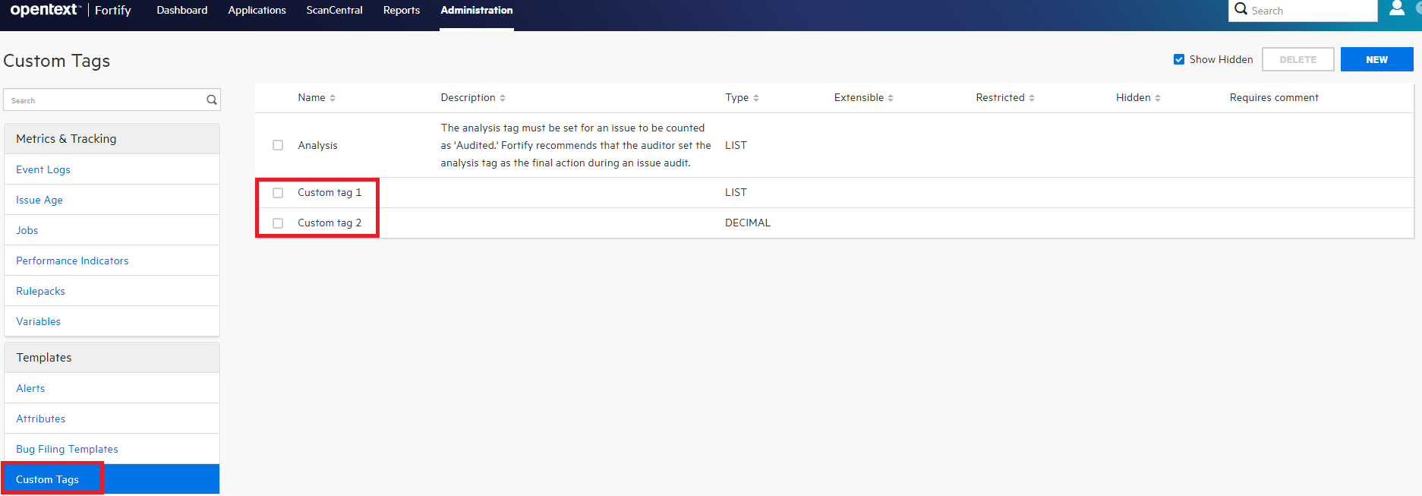
2). Go to Administration / Templates / Issue Templates
Click on out of the box “Prioritized High Risk Issue Template” and click on “Download Template”
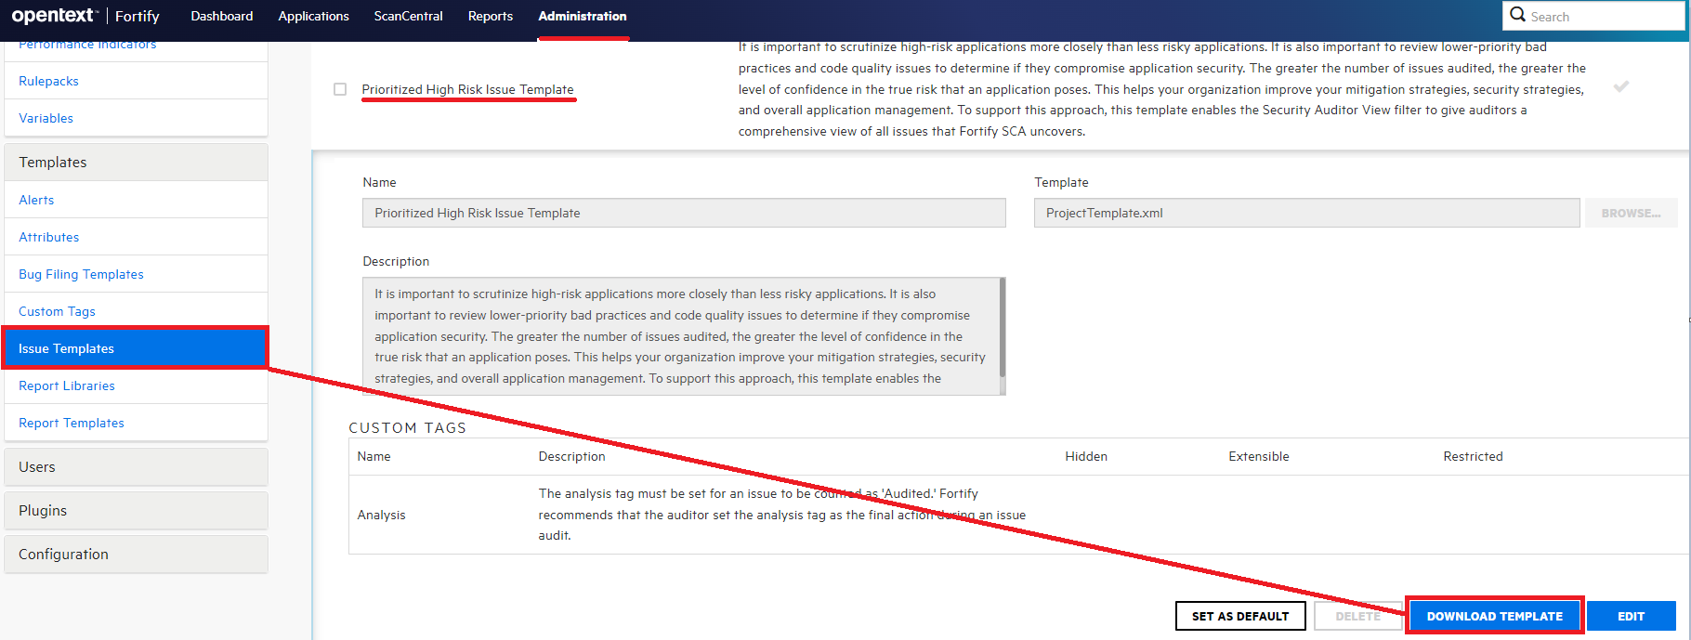

3). Create a New Issue Template:
Prioritized High Risk Issue Template_Luis
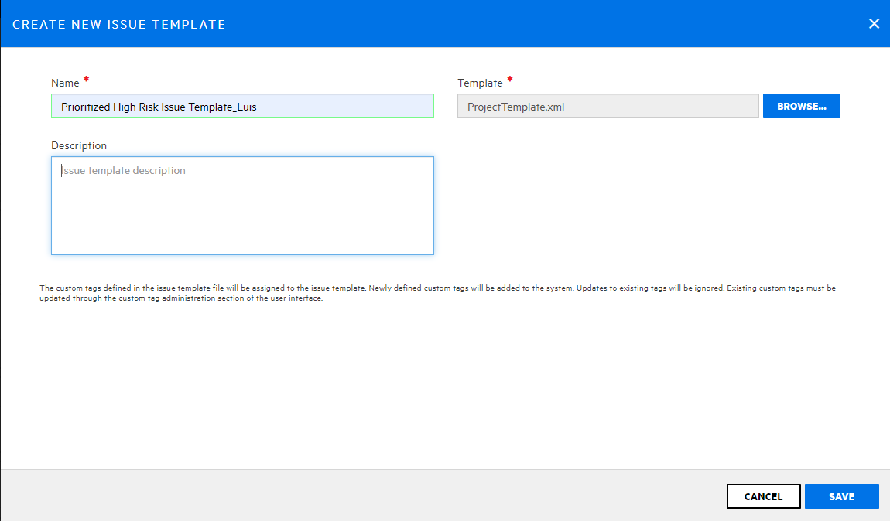
4). On the newly created Issue Template click on “Edit”.
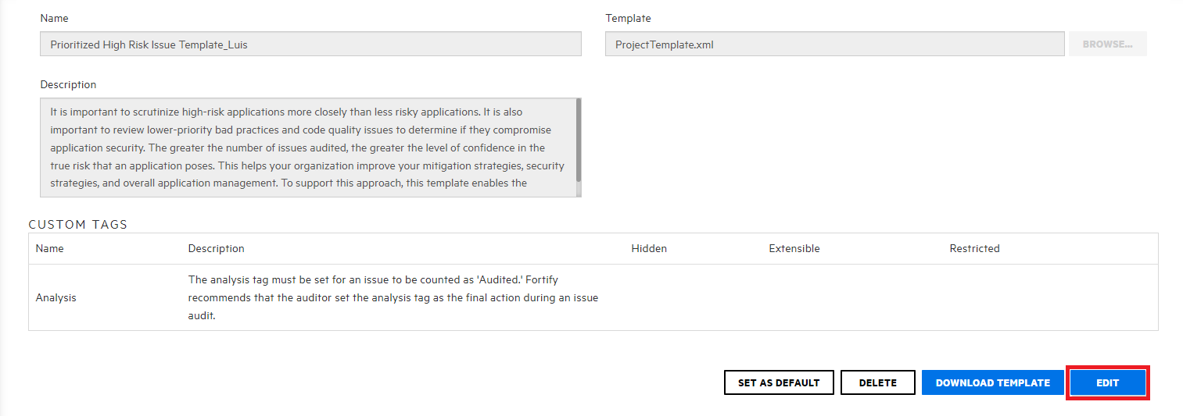
5). Click on “Add Custom Tag”
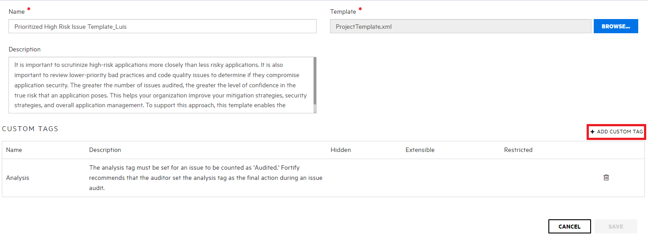
6). Add the custom tags to the template
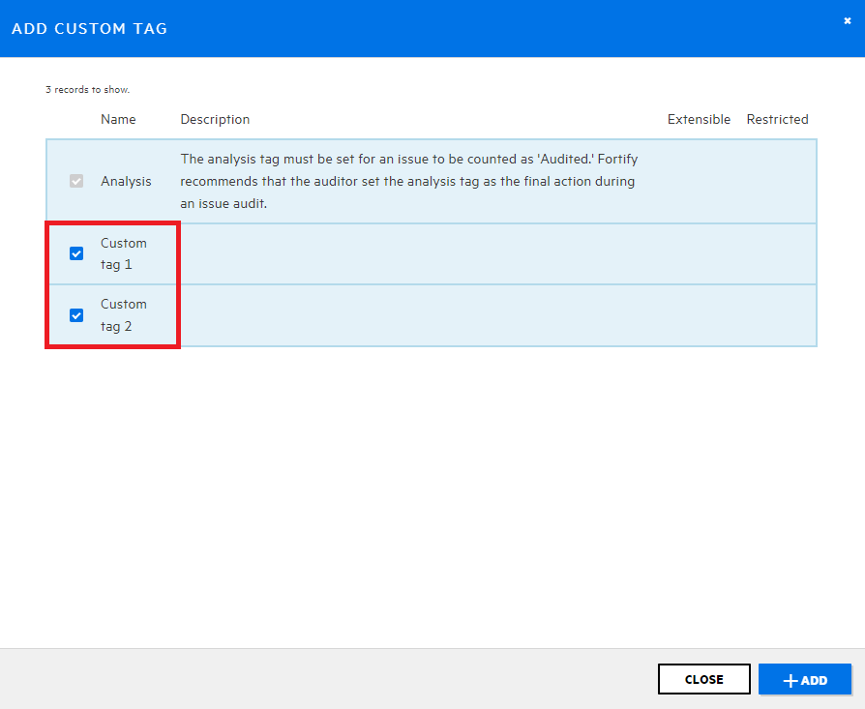
7). Click on “Save”
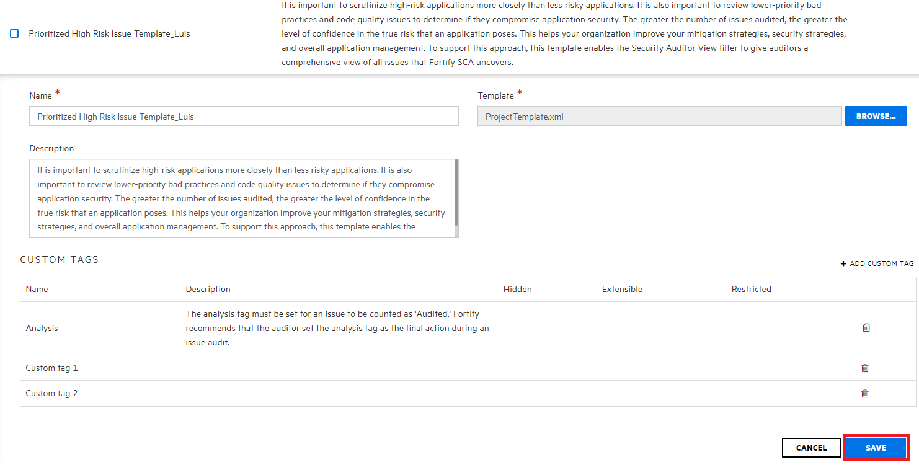
8). While creating a new Application under Template section choose the customer template that has the custom tags.
In this example choose template: Prioritized High Risk Issue Template_Luis
