Description:
How to collect Fortify Hosted ScanCentral SAST Assessment Azure Dev Ops Agent job log and YAML file for troubleshooting purposes.
Solution:
Section 1 - Enable Pipeline Debug mode before running the Pipeline:
1). When you click "Run Pipeline" click under Advanced options | Variables. Under "Value" set to True and click "Update". Then go back and run the Pipeline.
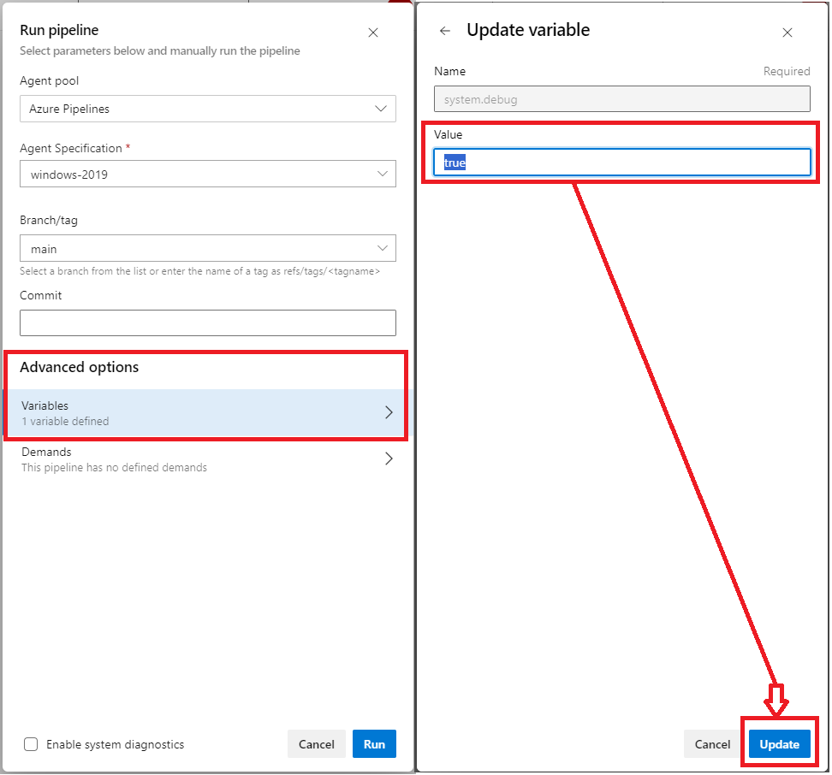

Section 2 - How to collect Fortify ScanCentral SAST Assessment Azure Azure Dev Ops Agent job log:
1). Please open the failed "Agent job" and click under "Run Fortify on Demand static assessment on".
2). Click on the upper right and choose "View raw log".
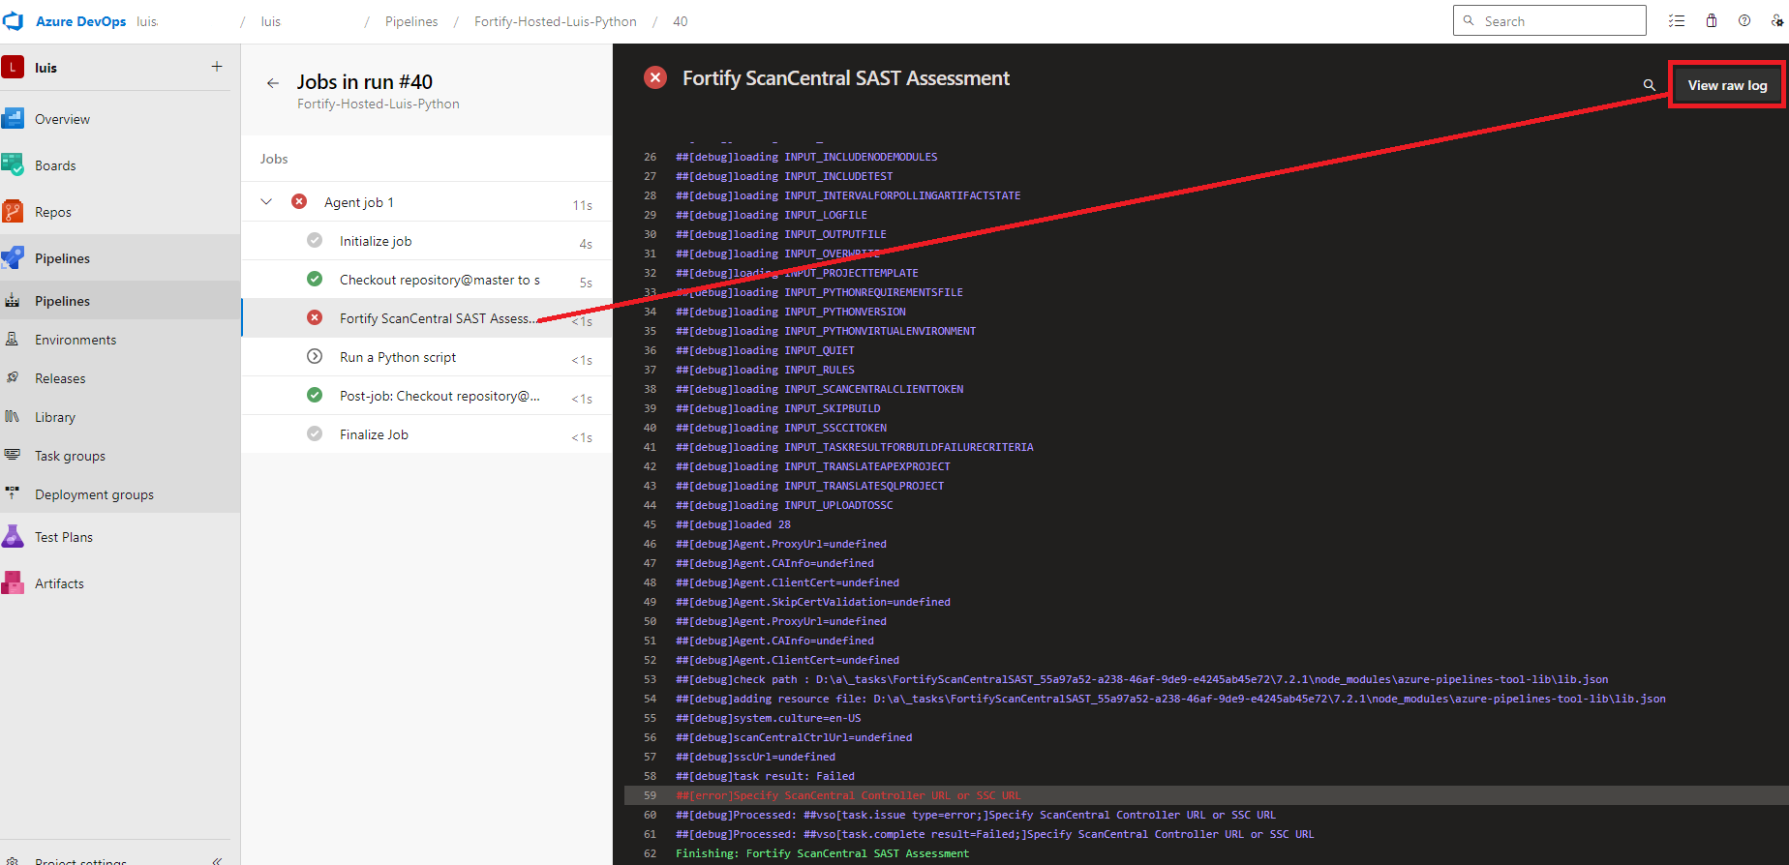
3). Once you see the log, please copy all the content, save it to a txt file and attach it to the support ticket.
Section 3 - How to collect Fortify ScanCentral SAST Assessment Azure Dev Ops YAML file:
1). Please open 'Recently run pipeline" and open under "Runs" the build.
2). Click on the upper right and choose "Edit pipeline".
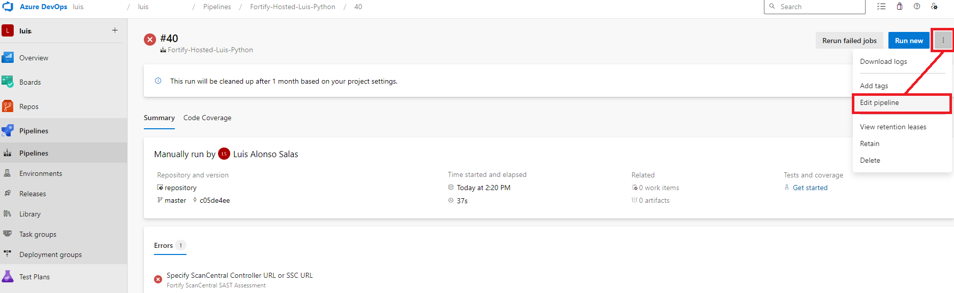
3). Click under Agent job: "Fortify ScanCentral SAST Assessment” and in the upper right click on option "View YAML".
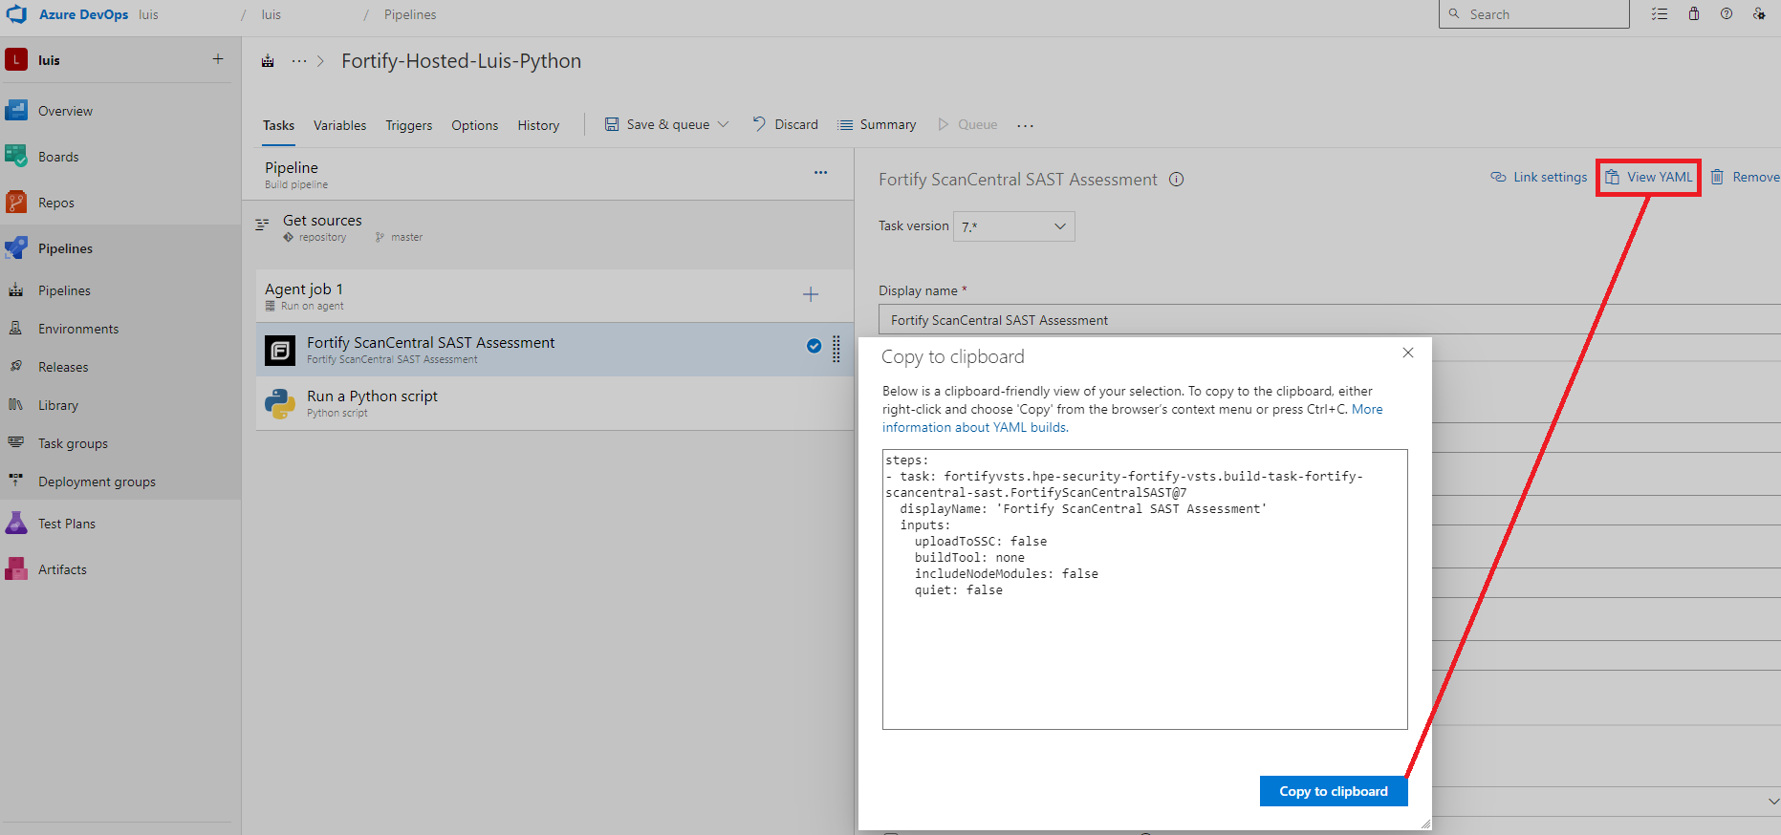

4). Copy to clipboard all the content, save it to a .txt file and attach it to the support ticket.

