Description
How to build a Fortify Hosted API query from Swagger to retrieve multiple priority issues
Solution
1). Go to https://<your_SSC_hosted_name>/html/docs/api-reference/index.jsp
2). Login with FortifyToken <SSC REST api token>
3). Search for: Project-version-controller
4). Use:
issue-of-project-version-controller Manage issues in the application version
list
GET /projectVersions/{parentId}issues
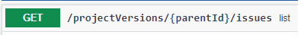
5). Under Parameters define:
fields string (query): id
q string (query): [fortify priority order]:high [fortify priority order]:medium
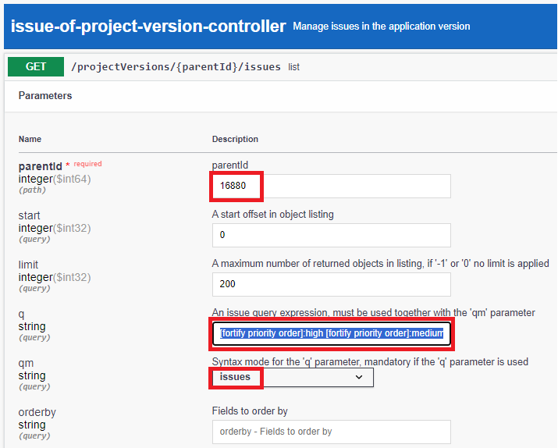
6). After you execute the query, you can see the curl command you can use from MS-DOS or terminal window and the query result.
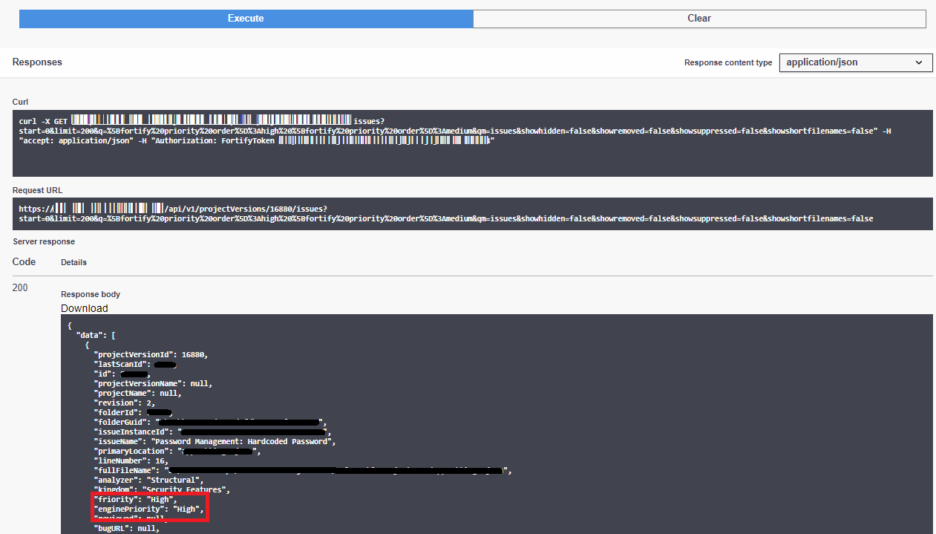
Curl query example:
curl -X GET "https://<your_SSC_hosted_name>/api/v1/projectVersions/16880/issues?start=0&limit=200&q=%5Bfortify%20priority%20order%5D%3Ahigh%20%5Bfortify%20priority%20order%5D%3Amedium&qm=issues&showhidden=false&showremoved=false&showsuppressed=false&showshortfilenames=false" -H "accept: application/json" -H "Authorization: FortifyToken <SSC REST api token>"
You can also apply the same filter from Fortify SSC portal under Audit Section for the desired project.
The following example does not have the filter (if you click under Syntax Guide.. you can see filters examples)
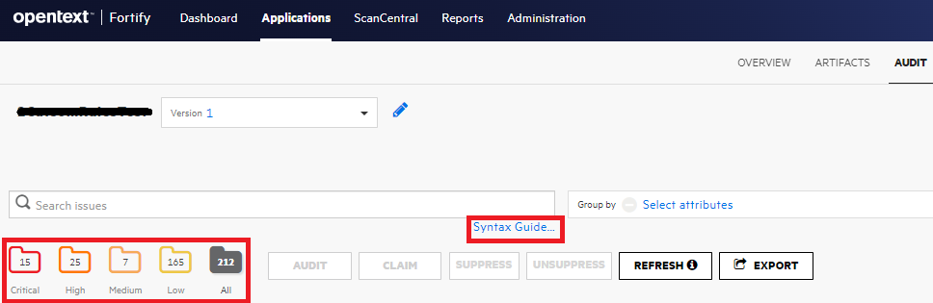
The following example has the filter applied:
