How to record a Login macro for zero.webappsecurity
1). Open Login Macro Recorder (TrueClient for WebInspect (TruClient Browser).
2). Paste in the right-hand window (TruClientBrowser) the URL and press enter.
http://zero.webappsecurity.com/
3). In the left-hand window click on the red circle (Start Recording).
4). Login to the URL entering the Username and Password and in the left-hand window click on the black square (Stop).
5). In the left-hand window click on the triangle (Replay) and see in the right-hand window it's displaying all what has been recorded.
6). Once Replay finishes you will see a pop-up window that ask you to choose one section on the webpage for the last step (Log out). Please make sure you choose a section that does not have unique identifier for the user that is logged in.
7). Finally, you can click on Save button to Save the Login Macro.
How to record a Login macro for zero.webappsecurity with pictures
1). Open Login Macro Recorder (TrueClient for WebInspect (TruClient Browser).
2). Paste in the right-hand window (TruClientBrowser) the URL and press enter.
http://zero.webappsecurity.com/
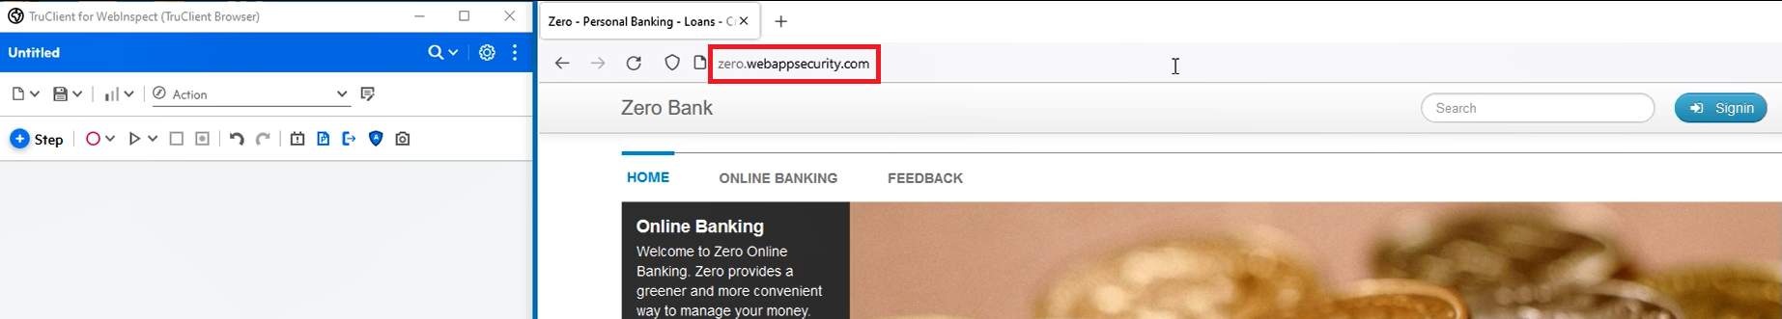
3). In the left-hand window click on the red circle (Start Recording).
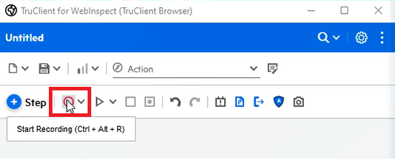
4). Login to the URL entering the Username and Password and in the left-hand window click on the black square (Stop).
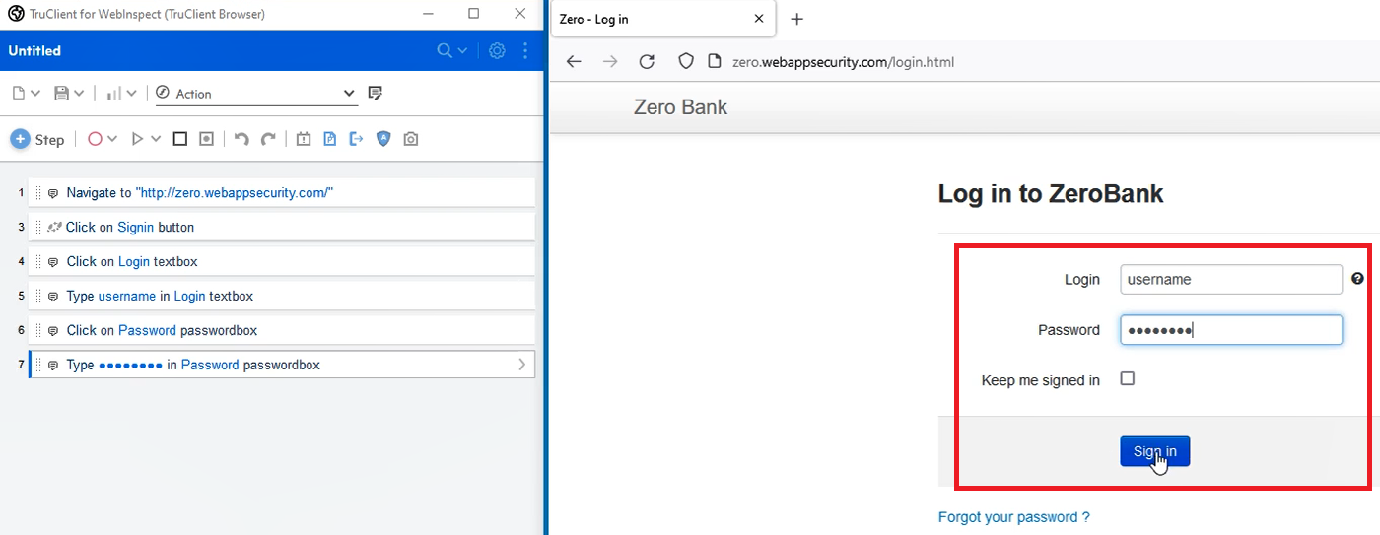
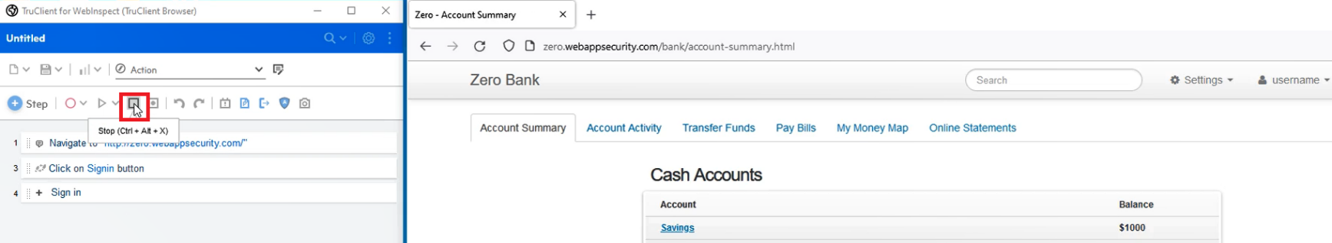
5). In the left-hand window click on the triangle (Replay) and see in the right-hand window it's displaying all what has been recorded.
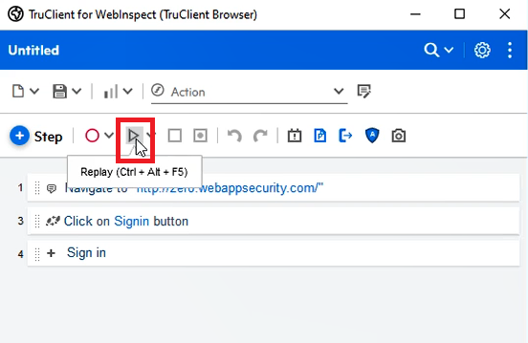
6). Once Replay finishes you will see a pop-up window that ask you to choose one section on the webpage for the last step (Log out). Please make sure you choose a section that does not have unique identifier for the user that is logged in.
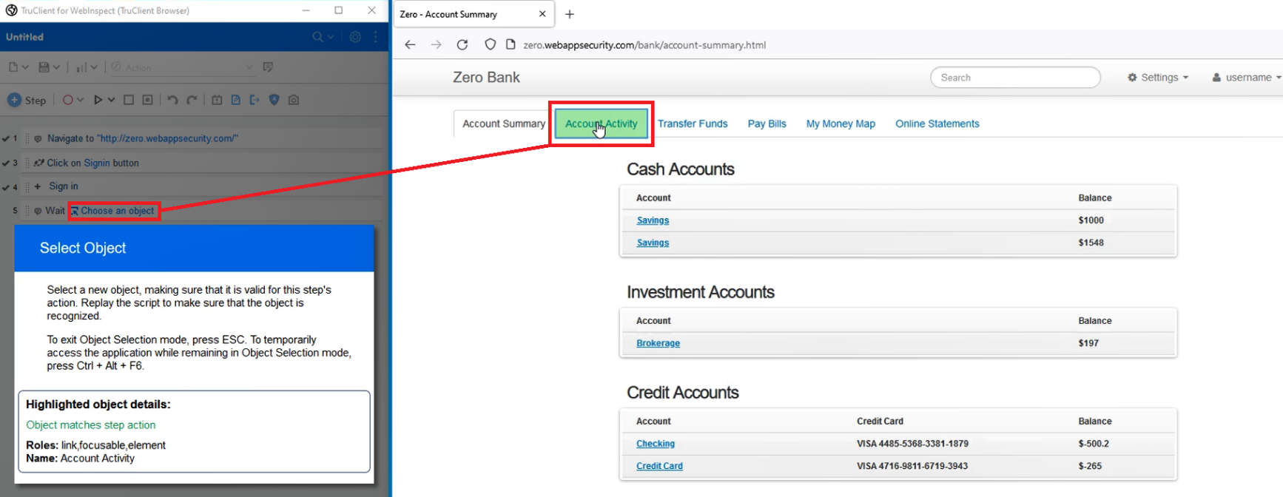
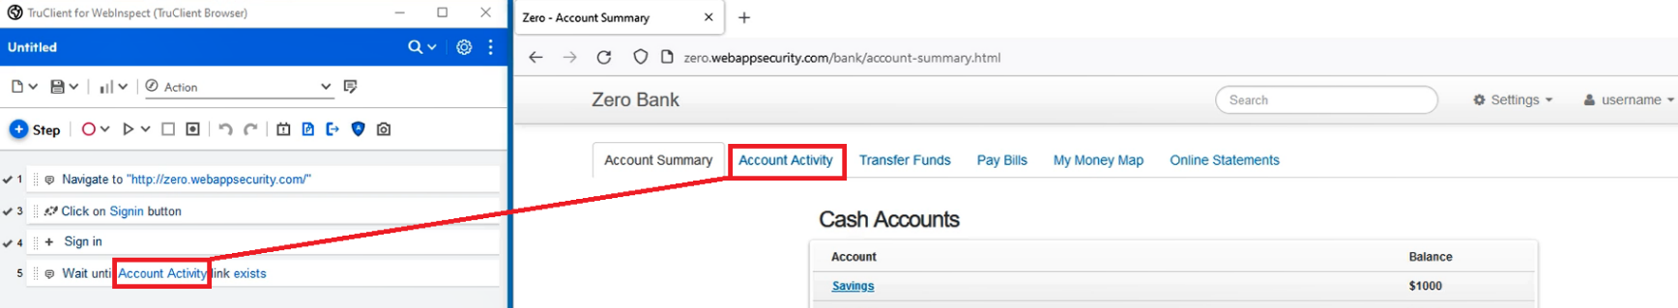
7). Finally, you can click on Save button to Save the Login Macro.
